Mechanical Engineers Summary
What Mechanical Engineers do
Mechanical engineers design, develop, build, and test mechanical and thermal sensors and devices, including tools, engines, and machines.

Work Environment
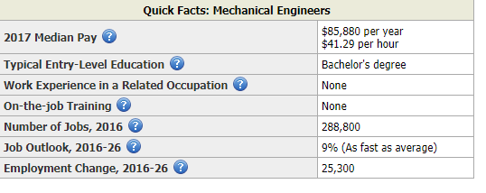
Mechanical engineers generally work in offices. They may occasionally visit worksites where a problem or piece of equipment needs their personal attention. Mechanical engineers work mostly in engineering services, research and development, and manufacturing.

How to Become a Mechanical Engineer
Mechanical engineers typically need a bachelor’s degree in mechanical engineering or mechanical engineering technology. All states and the District of Columbia require mechanical engineers who sell services to the public to be licensed.

Pay
The median annual wage for mechanical engineers was $85,880 in May 2017.

Job Outlook
Employment of mechanical engineers is projected to grow 9 percent from 2016 to 2026, as fast as the average for all occupations. Job prospects may be best for those who stay abreast of the most recent advances in technology.

State & Area Data
Explore resources for employment and wages by state and area for mechanical engineers.

Similar Occupations
Compare the job duties, education, job growth, and pay of mechanical engineers with similar occupations

